**LAB 2**

**Name: Syed Fahad Faheem Shah**

**ID: 23k-0062**

**Task 1:**

1. 47 + 39 + 60 + 85 + 64+54o-0Ah

**Code:**

include irvine32.inc

.data

.code

main proc

mov eax,47

add eax,39

add eax,60

add eax,85

add eax,64

add eax,54o

sub eax,0Ah

call writedec

exit

main endp

end main

**Output:**

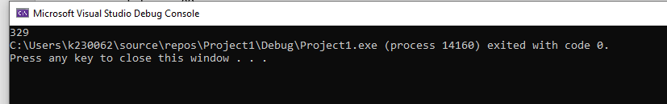

1. 30- 9 + 186 – 150

**Code:**

include irvine32.inc

.data

.code

main proc

mov eax,30

sub eax,9

add eax,186

sub eax,150

call writedec

exit

main endp

end main

**Output:**

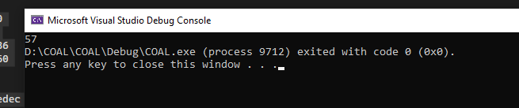

1. 101110 + 50Ah + 6710d + 1010001 + F

**Code:**

include irvine32.inc

.data

.code

main proc

mov eax,0101110b

add eax,050Ah

add eax,6710

add eax,01010001b

add eax,0Fh

call writedec

exit

main endp

end main

**Output:**

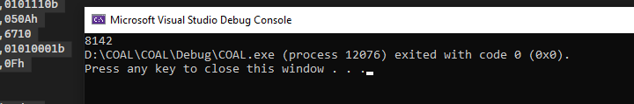

1. 10001101 – D83h + 385+10 + 1111101 – E+F

**Code:**

include irvine32.inc

.data

.code

main proc

mov eax,10001101b

sub eax,0D83h

add eax,385

add eax,10

add eax,1111101b

sub eax,0Eh

add eax,0Fh

call writeint

exit

main endp

end main

**Output:**

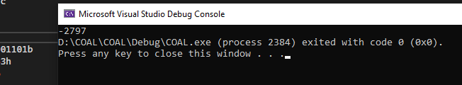

1. 101b- 9 + 1A4h – 569o

**Code:**

include irvine32.inc

.data

.code

main proc

mov eax,0101b

sub eax,9

add eax,01A4h

sub eax,377

call writeInt

exit

main endp

end main

**Output:**

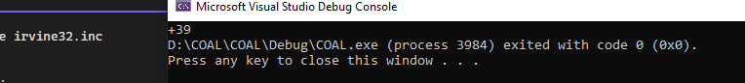

**Task 2:**

1. edx = eax + 1 + ebx– ecx + 0Ah-65o+73d

**Code:**

include irvine32.inc

.data

.code

main proc

mov eax,0

mov ebx,0

mov ecx,0

add eax,1

add eax,ebx

sub eax,ecx

add eax,0Ah

sub eax,065o

add eax,73

mov edx,eax

call dumpregs

exit

main endp

end main

**Output:**

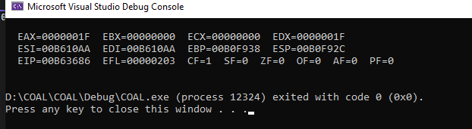

1. eax = 5ADh – ebx + 65o + 65d – 11110111 + 150

**Code:**

include irvine32.inc

.data

.code

main proc

mov ebx,0

mov eax, 05ADh

sub eax,ebx

add eax,065o

add eax,65

sub eax, 011110111b

add eax,150

call dumpregs

exit

main endp

end main

**Output:**

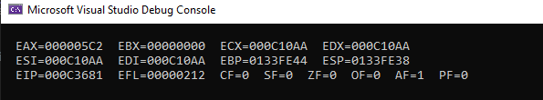

1. ebx = 5ADh – eax + 65d + 73o – 11100101 + 7Bh

**Code:**

include irvine32.inc

.data

.code

main proc

mov eax,0

mov ebx, 05ADh

sub ebx,eax

add ebx,65

add ebx,073o

sub ebx, 011100101b

add ebx,07Bh

call dumpregs

exit

main endp

end main

**Output:**

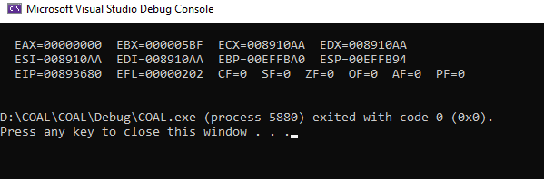

1. ecx = 110010101101b + 45h-73o + ebx -ecx + 1

**Code:**

include irvine32.inc

.data

.code

main proc

mov ebx,0

mov ecx,110010101101b

add ecx,045h

sub ecx,073o

add ecx,ebx

sub ecx,ecx

add ecx,1

call dumpregs

exit

main endp

end main

**Output:**

